Building the Model
The Market Valuation module is a Multiple Regression Analysis with Comparable Sales. The model is for only 510 properties in areas we have sufficient data.

Model Structure
This process starts with parcel to model mapping. The hierarchy goes as follows: Model > Cluster > NGROUP > NBHD > Parcel. The reason we do this is to group “like” properties for comparison. The county is made up of 6 Cluster.
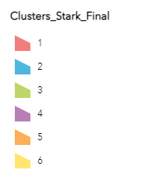
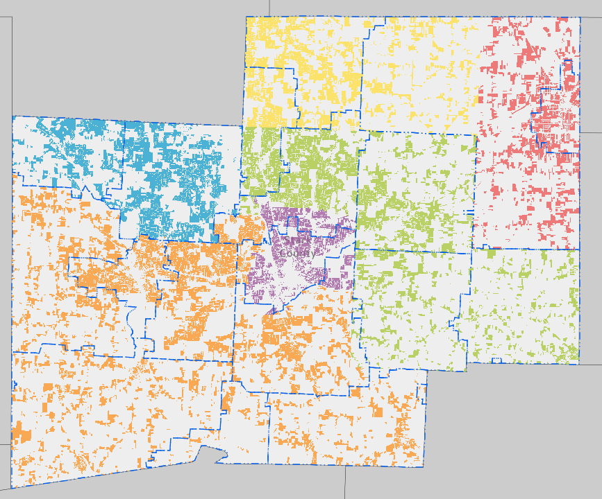
These clusters have neighborhood groups that are made up of neighborhoods.
Example:
Model | Cluster | NGroup | NBHD | DESCRIB
100 | 1 | 101 | RS10101 | ALLIANCE 1-01
100 | 1 | 101 | RS10102 | ALLIANCE 1-02
100 | 1 | 101 | RS10103 | ALLIANCE 1-03
100 | 1 | 101 | RS10202 | ALLIANCE 2-02
100 | 1 | 101 | RS10203 | ALLIANCE 2-03
100 | 1 | 101 | RS10301 | ALLIANCE 3-01
100 | 1 | 101 | RS10304 | ALLIANCE 3-04
100 | 1 | 102 | RS10201 | ALLIANCE 2-01
100 | 1 | 102 | RS10702 | ALLIANCE 7-02
100 | 1 | 102 | RS21101 | LEXINGTON
100 | 1 | 102 | RS21102 | OLD LIMAVILLE
*Note: Model 100 is divided into Cluster 1, NGROUP 1 (7 neighborhoods), and NGROUP 2 (4 neighborhoods).*
Clusters were influenced by our current zones. Then the NGROUP to NBHD mapping was completed by finding NBHD’s with properties that have similar characteristics. Such as: Year Built, Stories, Grade, CDU, Land Size, SFLA.

Sales Validation and Extraction
Once everything was mapped out. The next step is identifying sales to use for the model. Our office has been doing sale validation throughout the year every year. Now those sales had to be cleaned up and extracted to a sales history file. The clean up and extraction process happens every month. We do that by setting up the Sales Extract Parameters. Sales from 100-99,999,999 dollars with validity codes 0,1 from 1/1/2019 to 1/1/24. For this model we used 24,192 valid arm’s length transactions.

Regression Analysis and Variable Selection
The next step is creating and selecting variables for the regression analysis. This is an iterative process we had to run dozens of variables through the model to find the best preforming. Here’s an example of variable coefficient outputs.
Coefficients are adjustments made to comparable properties. The coefficient for SFLA in Cluster 2 for SFLA is 142.40. That mean the price per square foot adjustment for Cluster 2 is $142.
If you are curious about all the variables created. You can go to the Mksubval tab in Res transaction and view all of them. Note these are not all being used.

Comparable Property Selection
Now that we have the adjustments for the comparable properties. We now need to select the best comparable. That is done by weighting the attributes buyers use to make purchasing decisions. Some of these attributes are similar to variables used in the last section like SFLA or total baths. But some of these are only used a unit of comparison. Like pool, story height or NBHD.
Think of these weights like points.
Example:
Weight for SFLA in Cluster 2: 0.05 points per square foot difference.
Neighborhood (NBHD) Weight: 30 points if the comparable is outside the subject’s neighborhood.
The comparables with the lowest amount of points are ones selected.

Comp Selection Screen (SubjComp)
This brings us to the comp selection screen. It can only be accessed through residential transaction. And can be found in the Subjcomp tab.
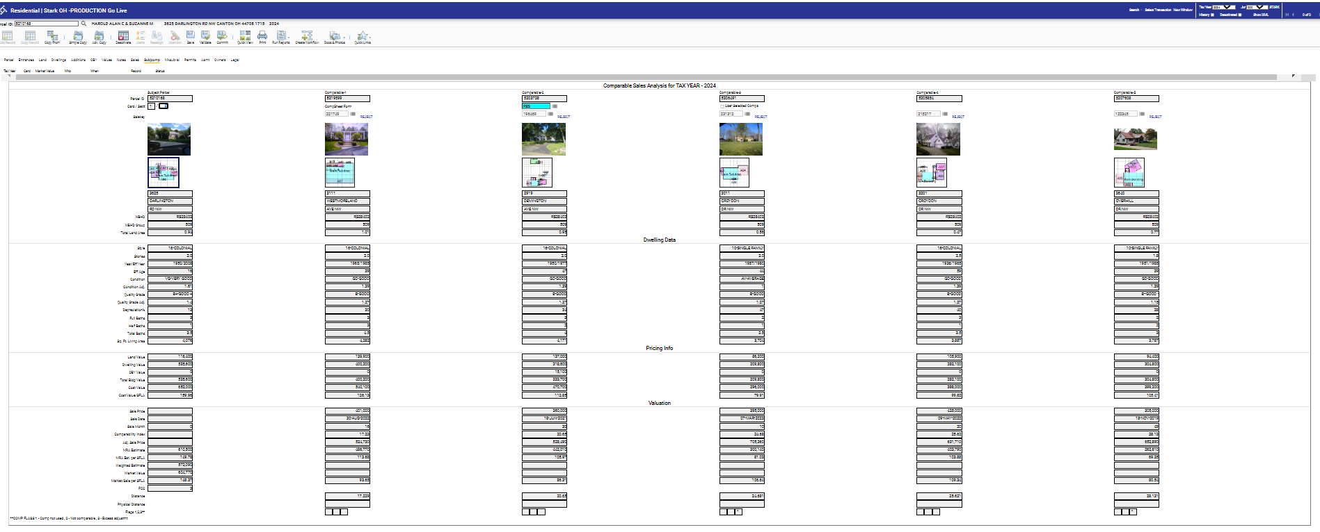
On the left-hand side, you will see the subject property followed by the comparable working to your right. The comparable are ordered from most to least comparable.

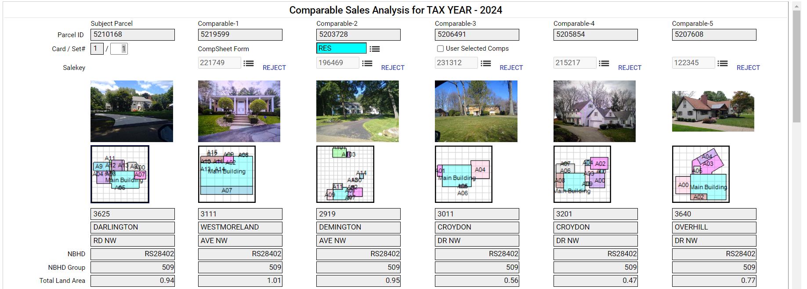
In these first section you will see location information about the subject and comparable. Such as Parcel number, sale key, address, NBHD, NBHD Group and total land area. This is what the model uses for location variables
The next section is dwelling data. These are attribute variable. Like we spoke about in the previous section these are used to find the most comparable properties. Then we use the coefficients to adjust the comparable.
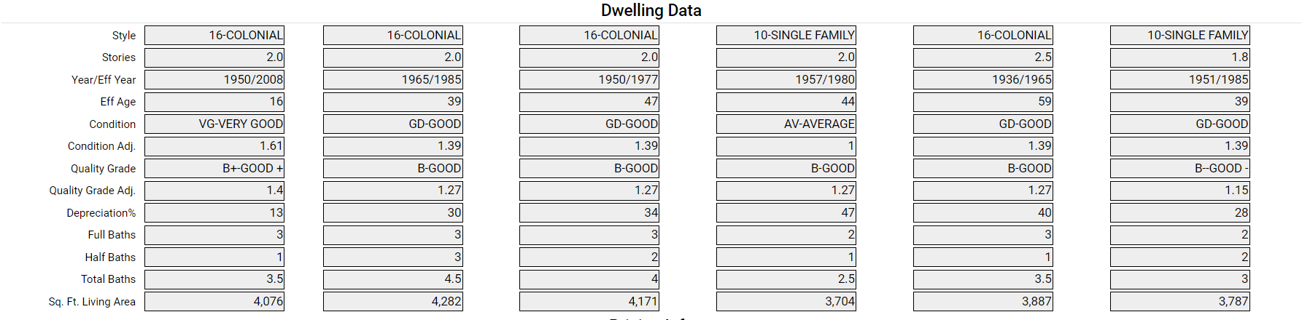
Next is the price info. All of this information is from our cost most. We are NOT adjusting for things like land or OBY in the market model at this time.
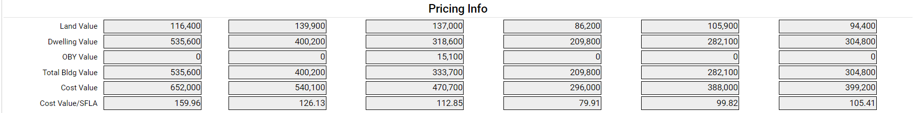
The final section is the valuation. Here you will find the sale price and date for the comparable. We do have a time adjustment built into the model. It is calculated from the number of months the sale is from the lean date 1/1/24.
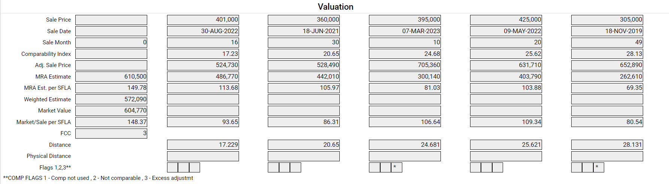
You’ll also find the comparability index in this section. This measures the closeness of the sale to the subject property in comparability. The comparability score provides a measure of which comparable properties should be utilized in the market approach. It is calculated using the sum of square differences of the comp property data and the subject property data. The square root of that score will then be the total comparability for that subject. The lower the score the more comparable. Under 50 is preferable.
The Adj. Sales price. This is calculated by (Comp+MRA Sub-MRA Comp). The MRA estimate is the predicted value from the multiple regression analysis. The weighted estimate which is only found on the subject property is computed from adjusted sales. And lastly you find the Market Value. Which is calculated by the subject MRA estimate, weighted estimate, and adjusted sales estimates with comparability scores less the max comparability score (400).
Below that you see FCC in the subject’s column. This is the ratio of standard deviation to the adjusted sales price.
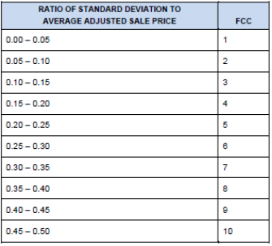
Than you’ll find Distance, Physical Distance and Flags. Distance and comparability index are the same measurement. Physical distance is the actual distance between the subject and comps using X Y coordinates. It is not being implemented yet. We hope to in the future.
Flag are an asterisk is displayed in each column to indicate:
1. Comparable was not used (comparability distance exceeded the Maximum comparability distance specified in the Parameter table for Market Valuation Runs setup form and was not among the first Minimum number of comparables).
2. Comparable was used but distance exceeded the Maximum comparability distance.
3. Percent adjustment to sale price (or dependent variable) exceeded 50% of the sale price (or dependent variable).

Selecting New Comparbles
If you find you do not like a comparable or would like to input you own comparable. Here is how you do that.
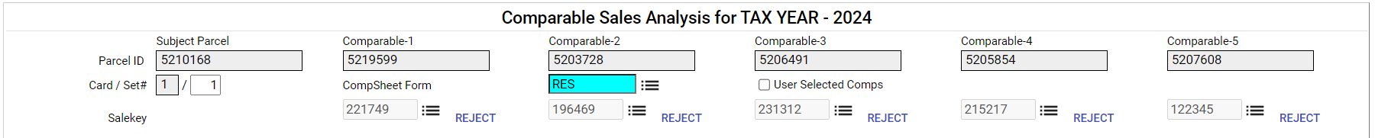
Above every comp you will see a button called reject. If you click that button it will remove the comp and automatically select a new comp and recalculate the market value.
If you’d like to input you own comp click the user selected comps box.
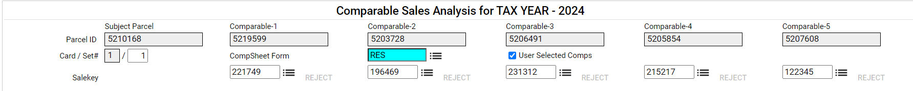
The sale key is no longer grayed out, you can now replace one or more sales using a new sale key. Or you can find a property by sale key or parcel number.
Click the three dashes under the comp you’d like to replace.
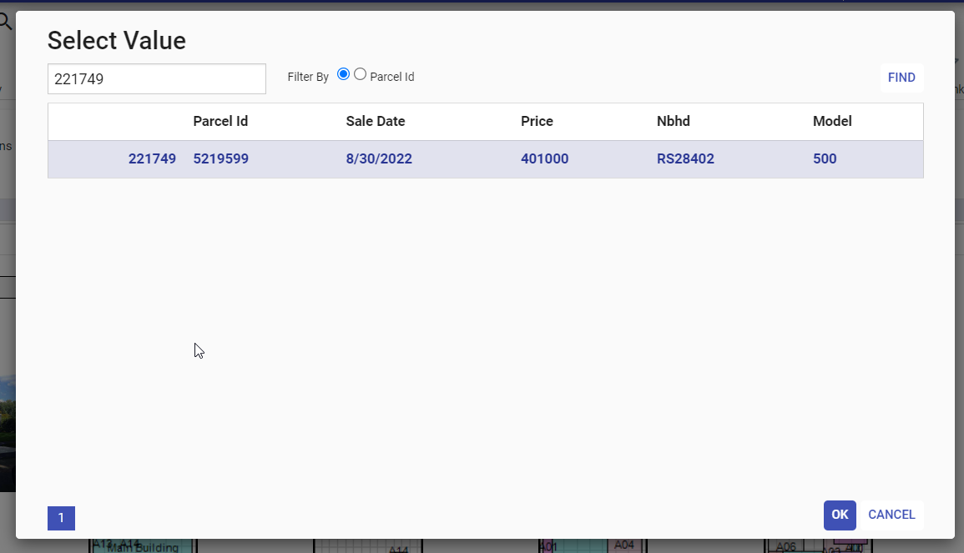
Delete the sale key number and enter the parcel you’d like to use. Once you select the new key click okay and validate the record. It will automatically resort the comp and recalculate the market value. The sale key or parcel number MUST be in the sales history file. So, if the sale occurred after 1/1/24 it will not be in the history file. Or if the sales do not fit any of the requirements from the sale history section of this manual. It will not be in the file.

Appeals
We will be using the market model as a test of reasonableness and defense against the cost model during appeals and BOR’s. We will NOT be using the valuation method Market Approach. If you’d like to use the market value, set the parcel to OVR, reason informal and enter the value.
For the BOR’s you can also create a PDF and attach it to your BOR report. Open the parcel in PRM. On the right hand side under reports, click comparables then GO.
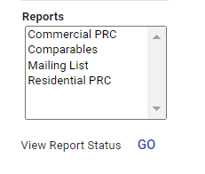
This will generate a PDF of the Subjcomp grid you and attach to your reports. At this time the map is not generating. We hope to have that fixed before BOR’s. If you’d like to see the map of the subject and comparable it can be found on PRM in the comparables tab.

Reference material
Model | Cluster | NGroup | NBHD | DESCRIB
100 | 1 | 101 | RS10101 | ALLIANCE 1-01
100 | 1 | 101 | RS10102 | ALLIANCE 1-02
100 | 1 | 101 | RS10103 | ALLIANCE 1-03
100 | 1 | 101 | RS10202 | ALLIANCE 2-02
100 | 1 | 101 | RS10203 | ALLIANCE 2-03
100 | 1 | 101 | RS10301 | ALLIANCE 3-01
100 | 1 | 101 | RS10304 | ALLIANCE 3-04
100 | 1 | 102 | RS10201 | ALLIANCE 2-01
100 | 1 | 102 | RS10702 | ALLIANCE 7-02
100 | 1 | 102 | RS21101 | LEXINGTON
100 | 1 | 102 | RS21102 | OLD LIMAVILLE
100 | 1 | 103 | RS10302 | ALLIANCE 3-02
100 | 1 | 103 | RS10308 | ALLIANCE 3-08
100 | 1 | 103 | RS10309 | ALLIANCE 3-09
100 | 1 | 103 | RS10310 | ALLIANCE 3-10
100 | 1 | 103 | RS10313 | ALLIANCE 3-13
100 | 1 | 103 | RS10402 | ALLIANCE 4-02
100 | 1 | 103 | RS10403 | ALLIANCE 4-03
100 | 1 | 103 | RS10701 | ALLIANCE 7-01
100 | 1 | 103 | RS10703 | ALLIANCE 7-03
100 | 1 | 103 | RS21201 | LEXINGTON 2-01
100 | 1 | 103 | RS10303 | ALLIANCE 3-03
100 | 1 | 104 | RS10306 | ALLIANCE 3-06
100 | 1 | 104 | RS10307 | ALLIANCE 3-07
100 | 1 | 104 | RS10311 | ALLIANCE 3-11
100 | 1 | 104 | RS10312 | ALLIANCE 3-12
100 | 1 | 104 | RS10401 | ALLIANCE 4-01
100 | 1 | 104 | RS10404 | ALLIANCE 4-04
100 | 1 | 104 | RS10405 | ALLIANCE 4-05
100 | 1 | 104 | RS10407 | ALLIANCE 4-07
100 | 1 | 104 | RS10412 | ALLIANCE 4-12
100 | 1 | 105 | RS32101 | WASHINGTON TWP 1
100 | 1 | 105 | RS32102 | WASHINGTON TWP 2
100 | 1 | 106 | RS10406 | ALLIANCE 4-06
100 | 1 | 106 | RS10501 | ALLIANCE 5-01
100 | 1 | 106 | RS10502 | ALLIANCE 5-02
100 | 1 | 106 | RS10503 | ALLIANCE 5-03
100 | 1 | 106 | RS10601 | ALLIANCE 6-01
100 | 1 | 106 | RS10602 | ALLIANCE 6-02
100 | 1 | 106 | RS10603 | ALLIANCE 6-03
100 | 1 | 106 | RS10604 | ALLIANCE 6-04
100 | 1 | 106 | RS10605 | ALLIANCE 6-05
100 | 2 | 201 | RS11101 | CANAL FULTON 1
100 | 2 | 201 | RS11102 | CANAL FULTON 2
100 | 2 | 201 | RS11103 | DENSHIRE VILLAGE
100 | 2 | 201 | RS11104 | CANAL FULTON 3
100 | 2 | 201 | RS11105 | AUTUMN MEADOW
100 | 2 | 201 | RS11106 | FULTON LANDINGS
100 | 2 | 201 | RS20103 | LAWRENCE NW 1
100 | 2 | 201 | RS20104 | LAWRENCE NW 2
100 | 2 | 201 | RS20105 | LAWRENCE NW 3
100 | 2 | 202 | RS18101 | JACKSON 1-01
100 | 2 | 202 | RS18201 | JACKSON 2-01
100 | 2 | 202 | RS18202 | JACKSON 2-02
100 | 2 | 202 | RS18203 | JACKSON 2-03
100 | 2 | 202 | RS18204 | JACKSON 2-04
100 | 2 | 202 | RS18206 | LAKE O SPRINGS VILLAGE
100 | 2 | 202 | RS18307 | JACKSON 3-07
100 | 2 | 204 | RS18301 | JACKSON 3-01
100 | 2 | 204 | RS18302 | WILLOWDALE LAKE
100 | 2 | 204 | RS18304 | JACKSON 3-04
100 | 2 | 204 | RS18306 | JACKSON 3-06
100 | 2 | 205 | RS18303 | JACKSON 3-03
100 | 2 | 205 | RS18305 | JACKSON 3-05
100 | 2 | 205 | RS18308 | JACKSON 3-08
100 | 2 | 205 | RS18602 | NOBLES POND
100 | 2 | 206 | RS18401 | JACKSON 4-01
100 | 2 | 206 | RS18402 | ROSE HILL VILLAS
100 | 2 | 206 | RS18501 | JACKSON 5-01
100 | 2 | 206 | RS18502 | JACKSON 5-02
100 | 2 | 206 | RS18503 | JACKSON 5-03
100 | 2 | 206 | RS18504 | JACKSON 5-04
100 | 2 | 206 | RS18505 | JACKSON 5-05
100 | 2 | 206 | RS18607 | JACKSON 6-07
100 | 2 | 207 | RS18603 | GLENMOOR
100 | 2 | 207 | RS18615 | SUARNAP
100 | 2 | 208 | RS18604 | JACKSON 6-04
100 | 2 | 208 | RS18605 | JACKSON 6-05
100 | 2 | 208 | RS18606 | AMESBURY HILLS
100 | 2 | 208 | RS18608 | JACKSON 6-08
100 | 2 | 208 | RS18609 | JACKSON 6-09
100 | 2 | 208 | RS18610 | ABERDEEN
100 | 2 | 208 | RS18611 | PROVIDENCE
100 | 2 | 208 | RS18612 | JACKSON 6-12
100 | 2 | 208 | RS18614 | GLENDALE VILLAGE
100 | 2 | 209 | RS18205 | LAKE CABLE
100 | 3 | 301 | RS12104 | CANTON CITY 1-04
100 | 3 | 301 | RS12107 | CANTON CITY 1-07
100 | 3 | 301 | RS12203 | CANTON CITY 2-03
100 | 3 | 301 | RS12208 | CANTON CITY 2-08
100 | 3 | 301 | RS14401 | NORTH CANTON 4-01
100 | 3 | 301 | RS14404 | NORTH CANTON 4-04
100 | 3 | 301 | RS28302 | PLAIN 3-02
100 | 3 | 301 | RS28303 | FRAZER COURT
100 | 3 | 302 | RS12105 | CANTON CITY 1-05
100 | 3 | 302 | RS12106 | CANTON CITY 1-06
100 | 3 | 302 | RS28102 | LAUREL RIDGE
100 | 3 | 302 | RS28104 | ALPINE LAKE
100 | 3 | 302 | RS28208 | PLAIN 2-08
100 | 3 | 302 | RS28601 | PLAIN 6-01
100 | 3 | 302 | RS28605 | PLAIN 6-05
100 | 3 | 302 | RS28606 | PLAIN 6-06
100 | 3 | 302 | RS28701 | PLAIN 7-01
100 | 3 | 302 | RS28702 | PLAIN 7-02
100 | 3 | 302 | RS28706 | PLAIN 7-06
100 | 3 | 303 | RS12202 | CANTON CITY 2-02
100 | 3 | 303 | RS14104 | NORTH CANTON 1-04
100 | 3 | 303 | RS14107 | NORTH CANTON 1-07
100 | 3 | 303 | RS14203 | NORTH CANTON 2-03
100 | 3 | 303 | RS14301 | NORTH CANTON 3-01
100 | 3 | 303 | RS14302 | NORTH CANTON 3-02
100 | 3 | 303 | RS14303 | SURREY HILL
100 | 3 | 303 | RS14304 | NORTH CANTON 3-04
100 | 3 | 303 | RS14402 | NORTH CANTON 4-02
100 | 3 | 303 | RS14403 | EASTWOODS
100 | 3 | 303 | RS28311 | PLAIN 3-11
100 | 3 | 303 | RS28401 | PLAIN 4-01
100 | 3 | 303 | RS28501 | PLAIN 5-01
100 | 3 | 304 | RS12502 | THE QUARRY
100 | 3 | 305 | RS14101 | SANCTUARY
100 | 3 | 305 | RS14102 | NORTH CANTON 1-02
100 | 3 | 305 | RS14108 | MONTICELLO
100 | 3 | 305 | RS14405 | MAGNOLIA
100 | 3 | 305 | RS28306 | BOB-O-LINK ESTATES
100 | 3 | 305 | RS28309 | PLAIN 3-09
100 | 3 | 305 | RS28310 | PLAIN 3-10
100 | 3 | 306 | RS14103 | NORTH CANTON 1-03
100 | 3 | 306 | RS14106 | NORTH CANTON 1-06
100 | 3 | 306 | RS14109 | NORTH CANTON 1-09
100 | 3 | 306 | RS14201 | AMESBURY
100 | 3 | 306 | RS14202 | NORTH CANTON 2-02
100 | 3 | 306 | RS28301 | PLAIN 3-01
100 | 3 | 306 | RS28307 | PLAIN 3-07
100 | 3 | 306 | RS28308 | PLAIN 3-08
100 | 3 | 306 | RS28312 | PLAIN 3-12
100 | 3 | 307 | RS14105 | WASHINGTON SQUARE
100 | 3 | 307 | RS28103 | SARATOGA HILLS
100 | 3 | 307 | RS28204 | WELLINGTON HILLS
100 | 3 | 307 | RS28205 | WELLINGTON WOODS
100 | 3 | 307 | RS28206 | LEXINGTON FARMS
100 | 3 | 307 | RS28207 | HUNTERS RIDGE
100 | 3 | 307 | RS28209 | STONEHEDGE
100 | 3 | 307 | RS28211 | THE FOUNTAINS AT EDGEWOOD 1
100 | 3 | 307 | RS28304 | PLAIN 3-04
100 | 3 | 307 | RS28602 | KINGS CREEK
100 | 3 | 307 | RS28603 | LAKES AT KINGS CREEK
100 | 3 | 307 | RS28703 | CANTERBURY CREEK
100 | 3 | 309 | RS15101 | STONEBRIDGE
100 | 3 | 309 | RS15204 | LOUISVILLE 2-04
100 | 3 | 309 | RS15301 | LOUISVILLE 3-01
100 | 3 | 309 | RS15302 | LOUISVILLE 3-02
100 | 3 | 309 | RS15502 | LOUISVILLE 5-02
100 | 3 | 309 | RS15503 | LOUISVILLE 5-03
100 | 3 | 309 | RS23101 | NIMISHILLEN 1-01
100 | 3 | 309 | RS23201 | NIMISHILLEN 2-01
100 | 3 | 309 | RS23202 | NIMISHILLEN 2-02
100 | 3 | 310 | RS15102 | LOUISVILLE 1-02
100 | 3 | 310 | RS15201 | LOUISVILLE 2-01
100 | 3 | 310 | RS15202 | LOUISVILLE 2-02
100 | 3 | 310 | RS15203 | GLENBROOK VILLAGE
100 | 3 | 310 | RS15501 | LOUISVILLE 5-01
100 | 3 | 310 | RS23301 | NIMISHILLEN 3-01
100 | 3 | 311 | RS24101 | OSNABURG
100 | 3 | 311 | RS35101 | EAST CANTON
100 | 3 | 312 | RS25101 | PARIS
100 | 3 | 312 | RS41101 | MINERVA 1
100 | 3 | 312 | RS41102 | MINERVA 2
100 | 3 | 313 | RS28101 | PLAIN 1-01
100 | 3 | 313 | RS28105 | WICKER CREEK
100 | 3 | 313 | RS28201 | PLAIN 2-01
100 | 3 | 313 | RS28202 | PLAIN 2-02
100 | 3 | 313 | RS28203 | PLAIN 2-03
100 | 3 | 313 | RS28210 | PANTHER ESTATES
100 | 4 | 401 | RS12111 | CANTON CITY 1-11
100 | 4 | 401 | RS12214 | MARKET HEIGHTS
100 | 4 | 401 | RS12218 | HISTORIC RIDGEWOOD
100 | 4 | 401 | RS28604 | PLAIN 6-04
100 | 4 | 401 | RS28705 | PLAIN 7-05
100 | 4 | 402 | RS12119 | CANTON CITY 1-19
100 | 4 | 402 | RS12124 | CANTON CITY 1-24
100 | 4 | 403 | RS12120 | CANTON CITY 1-20
100 | 4 | 403 | RS12121 | CANTON CITY 1-21
100 | 4 | 403 | RS12122 | CANTON CITY 1-22
100 | 4 | 403 | RS12123 | CANTON CITY 1-23
100 | 4 | 403 | RS28704 | PLAIN 7-04
100 | 4 | 404 | RS12132 | CANTON CITY 1-32
100 | 4 | 404 | RS12133 | CANTON CITY 1-33
100 | 4 | 404 | RS12134 | CANTON CITY 1-34
100 | 4 | 404 | RS12231 | CANTON CITY 2-31
100 | 4 | 404 | RS12330 | CANTON CITY 3-30
100 | 4 | 404 | RS12437 | CANTON CITY 4-37
100 | 4 | 404 | RS12535 | CANTON CITY 5-35
100 | 4 | 404 | RS12536 | CANTON CITY 5-36
100 | 4 | 404 | RS17101 | CANTON TWP 1-01
100 | 4 | 405 | RS12201 | CANTON CITY 2-01
100 | 4 | 405 | RS12210 | CANTON CITY 2-10
100 | 4 | 405 | RS12212 | CANTON CITY 2-12
100 | 4 | 405 | RS12213 | CANTON CITY 2-13
100 | 4 | 405 | RS28502 | PLAIN 5-02
100 | 4 | 406 | RS12215 | CANTON CITY 2-15
100 | 4 | 406 | RS12217 | CANTON CITY 2-17
100 | 4 | 406 | RS12225 | CANTON CITY 2-25
100 | 4 | 406 | RS12226 | CANTON CITY 2-26
100 | 4 | 408 | RS12327 | CANTON CITY 3-27
100 | 4 | 408 | RS12329 | THE FAIRGROUNDS
100 | 4 | 408 | RS12438 | CANTON CITY 4-38
100 | 4 | 408 | RS12441 | CANTON CITY 4-41
100 | 4 | 408 | RS12442 | CANTON CITY 4-42
100 | 4 | 408 | RS12543 | CANTON CITY 5-43
100 | 4 | 408 | RS12545 | VIENNA WOODS
100 | 5 | 501 | RS12328 | HARTER HEIGHTS
100 | 5 | 501 | RS12440 | CANTON CITY 4-40
100 | 5 | 501 | RS13450 | MASSILLON 4-50
100 | 5 | 501 | RS17102 | CANTON TWP 1-02
100 | 5 | 501 | RS17204 | CANTON TWP 2-04
100 | 5 | 501 | RS18616 | JACKSON 6-16
100 | 5 | 501 | RS26101 | PERRY 1-01
100 | 5 | 501 | RS26102 | PERRY 1-02
100 | 5 | 501 | RS26108 | PERRY 1-08
100 | 5 | 501 | RS26202 | PERRY 2-02
100 | 5 | 501 | RS26203 | PERRY 2-03
100 | 5 | 501 | RS28403 | PLAIN 4-03
100 | 5 | 501 | RS40101 | MEYERS LAKE
100 | 5 | 502 | RS13101 | MASSILLON 1-01
100 | 5 | 502 | RS13102 | MASSILLON 1-02
100 | 5 | 502 | RS13104 | MASSILLON 1-04
100 | 5 | 502 | RS13109 | MASSILLON 1-09
100 | 5 | 502 | RS13512 | THE LEGENDS
100 | 5 | 502 | RS13601 | GRAY RIDGE ESTATES
100 | 5 | 502 | RS18617 | JACKSON 6-17
100 | 5 | 502 | RS26103 | PERRY 1-03
100 | 5 | 502 | RS26104 | PERRY 1-04
100 | 5 | 502 | RS26106 | PERRY 1-06
100 | 5 | 502 | RS26107 | PERRY 1-07
100 | 5 | 502 | RS26109 | PERRY 1-09
100 | 5 | 502 | RS26204 | BISHOP MEADOWS
100 | 5 | 502 | RS26303 | PERRY 3-03
100 | 5 | 503 | RS13103 | MASSILLON 1-03
100 | 5 | 503 | RS13105 | MASSILLON 1-05
100 | 5 | 503 | RS13106 | MASSILLON 1-06
100 | 5 | 503 | RS13107 | MASSILLON 1-07
100 | 5 | 503 | RS13212 | MASSILLON 2-12
100 | 5 | 503 | RS13213 | MASSILLON 2-13
100 | 5 | 503 | RS13316 | MASSILLON 3-16
100 | 5 | 503 | RS13416 | MASSILLON 4-16
100 | 5 | 503 | RS13608 | MASSILLON 6-08
100 | 5 | 504 | RS13214 | MASSILLON 2-14
100 | 5 | 504 | RS13219 | MASSILLON 2-19
100 | 5 | 504 | RS13315 | MASSILLON 3-15
100 | 5 | 504 | RS13418 | MASSILLON 4-18
100 | 5 | 504 | RS20101 | LAWRENCE TUSLAW 1
100 | 5 | 504 | RS20102 | LAWRENCE TUSLAW 2
100 | 5 | 504 | RS31101 | TUSCARAWAS TWP 1
100 | 5 | 504 | RS31102 | TUSCARAWAS TWP 2
100 | 5 | 504 | RS31103 | TUSCARAWAS TWP 3
100 | 5 | 505 | RS13509 | SHRIVER
100 | 5 | 505 | RS13511 | WALNUT HILLS
100 | 5 | 505 | RS13607 | MASSILLON 6-07
100 | 5 | 506 | RS16101 | BETHLEHEM 1-01
100 | 5 | 506 | RS26201 | PERRY 2-01
100 | 5 | 506 | RS26301 | PERRY 3-01
100 | 5 | 506 | RS26302 | PERRY 3-02
100 | 5 | 506 | RS26304 | PERRY 3-04
100 | 5 | 506 | RS26305 | PERRY 3-05
100 | 5 | 506 | RS26306 | PERRY 3-06
100 | 5 | 506 | RS26307 | PERRY 3-07
100 | 5 | 506 | RS42101 | NAVARRE VILLAGE RES AGR
100 | 5 | 507 | RS17201 | CANTON TWP 2-01
100 | 5 | 507 | RS17202 | CANTON TWP 2-02
100 | 5 | 507 | RS17203 | CANTON TWP 2-03
100 | 5 | 507 | RS17206 | CANTON TWP 2-06
100 | 5 | 507 | RS27101 | PIKE TWP
100 | 5 | 507 | RS36101 | EAST SPARTA
100 | 5 | 509 | RS26105 | PERRY 1-05
100 | 5 | 509 | RS28402 | AVONDALE
100 | 5 | 509 | RS38101 | HILLS & DALES VILLAGE
100 | 5 | 510 | RS29101 | SANDY TWP
100 | 5 | 510 | RS29102 | WAYNESBURG GROVE
100 | 5 | 510 | RS39101 | MAGNOLIA VILLAGE
100 | 5 | 510 | RS43101 | WAYNESBURG VILLAGE
100 | 5 | 510 | RS43102 | EVERGREEN ACRES
100 | 5 | 511 | RS30101 | SUGARCREEK TWP
100 | 5 | 511 | RS33101 | BEACH CITY VILLAGE
100 | 5 | 511 | RS34101 | BREWSTER VILLAGE
100 | 5 | 511 | RS44101 | WILMOT VILLAGE
100 | 6 | 601 | RS19101 | LAKE 1-01
100 | 6 | 601 | RS19104 | LAKE 1-04
100 | 6 | 601 | RS19105 | LAKE 1-05
100 | 6 | 601 | RS19201 | LAKE 2-01
100 | 6 | 601 | RS19226 | LAKE 2-26
100 | 6 | 601 | RS37101 | HARTVILLE 1-01
100 | 6 | 601 | RS37104 | HARTVILLE 1-04
100 | 6 | 602 | RS19102 | CONGRESS LAKE
100 | 6 | 602 | RS19106 | LAKE 1-06
100 | 6 | 602 | RS37102 | DANBURY GLEN
100 | 6 | 602 | RS19114 | COUNTRY CLUB ESTATES
100 | 6 | 603 | RS19103 | LAKE 1-03
100 | 6 | 603 | RS19107 | LAKE 1-07
100 | 6 | 603 | RS19108 | WILLIAMSBURG VILLAGE ESTATES
100 | 6 | 603 | RS19109 | PEPPERTREE ESTATES
100 | 6 | 603 | RS19215 | LAKE 2-15
100 | 6 | 603 | RS19216 | SPRINGWATER GARDENS
100 | 6 | 604 | RS19110 | LAKE 1-10
100 | 6 | 604 | RS19111 | LAKE 1-11
100 | 6 | 604 | RS19112 | LAKE 1-12
100 | 6 | 604 | RS19113 | UNIONTOWN
100 | 6 | 604 | RS19220 | LAKE 2-20
100 | 6 | 605 | RS19202 | GREENTREE
100 | 6 | 605 | RS19203 | THE BOROUGHS
100 | 6 | 605 | RS19204 | CRICKET CROSSING
100 | 6 | 605 | RS19205 | LAKE 2-05
100 | 6 | 605 | RS19221 | LAKE 2-21
100 | 6 | 605 | RS19222 | FOREST MEADOWS
100 | 6 | 605 | RS19223 | FAIRWYNDE GLENS
100 | 6 | 605 | RS19227 | GLENGARRY
100 | 6 | 606 | RS19206 | SHEPHERDS GATE
100 | 6 | 606 | RS19210 | ST IVES
100 | 6 | 606 | RS19214 | SAINT JAMES PLACE
100 | 6 | 607 | RS19207 | GREENTOWN
100 | 6 | 607 | RS19209 | PHEASANT VALLEY
100 | 6 | 607 | RS19211 | LAKE 2-11
100 | 6 | 607 | RS19212 | HIGHLAND CREEK
100 | 6 | 607 | RS19213 | LAKE 2-13
100 | 6 | 608 | RS19217 | HERITAGE GLEN
100 | 6 | 608 | RS19218 | THE ENCLAVE
100 | 6 | 608 | RS19219 | THE HIGHLANDS
100 | 6 | 608 | RS19224 | HOOVER ESTATES
100 | 6 | 608 | RS19225 | LAKE 2-25
100 | 6 | 608 | RS37103 | HARTVILLE 1-03
100 | 6 | 608 | RS37105 | THE WOODLANDS
100 | 6 | 609 | RS22101 | MARLBORO

